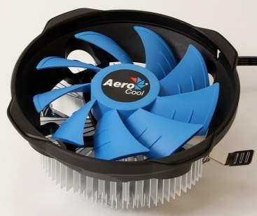

Product Overview:
Universal air cooling solution compatible with most current AMD and Intel motherboard designs. Equipped with high efficiency fins and compact profile. Not compatible with Intel 2011 and 2066.
Specifications

Model |  | BAS U-3P
Base Material |  | Aluminum
Dimension |  | 131 x 131 x 62mm
TDP(Thermal Design Power) |  | 110
Fan | Speed | 1800 rpm
 | Connector | 3-Pin
 | Dimension | 120 x 120 x 25mm
 | Bearing Type | Hydraulic Bearing
 | Started Voltage | 5V
 | Rated Voltage | 12V
 | Rated Current | 0.3 A
 | Power Consumption | 3.6 Watts
 | Air Pressure | 1.22 mm-H2O
 | Air Flow | 59.8 CFM
 | Noise | 26.3dBA
 | MTBF  (Mean Time Before Failure) | 60000 hrs.
Socket |  | LGA 1156/1155/1151/1150/775 AM4/AM3+/AM3/AM2+/AM2/FM2/FM1

Warranty

1 year

Features
- TDP (Thermal Design Power) up to 110W.
- Upgraded high efficiency fins with maximum thermal performance.
- Compact profile capable of mounting single 120mm fan configurations; works with most current AMD and Intel motherboard designs. Not compatible with Intel 2011 and 2066.

Package Information

Product Name | Product Number | EAN CODE | UPC CODE
BAS U-3P
Carton Size ( L x W x H ) | 566 x 430 x 380 mm | Carton Weight
Retail Box Size ( L x W x H ) |  | Retail Box Weight
Carton Qty | 60 pcs | Pallet Qty

